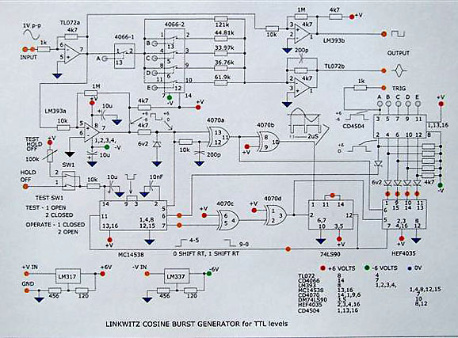

I have recently constructed your burst generator with some modifications to cater for currently available IC's.

The supply of the 74C90 proved to be the problem, all other IC's are still available in CMOS, so I decided to run all of the timing portion at TTL levels allowing a 74LS90 to be substituted for the 74C90.

The analog switches remain as designed with a TTL to CMOS level converter, CD4504, providing the interface between the TTL logic and CMOS analog components.
A 6v2 zener diode fed via a 4k7 resistor converts the LM393a 12v p-p square wave to TTL level.
At the o/p of the CD4035, a set of five 6v2 zeners are used to shift the TTL level to the CMOS negative reference rail at the i/p to the CD4504 TTL to CMOS level converter.
All IC's can be supplied from Digikey.

The solution for the replacement of one IC is rather convoluted, however I wanted to make the burst generator and this was the fastest way for me without redesigning the wheel.
The additional cost is insignificant for a very useful item of test equipment.
I have utilised the second half of the LM393 as a square wave generator, and also added a test switch and pot which could well be disposed of but were handy while checking out the mods.

Ray Hernan, hernanr@netspace.net.au
Tasmania, 12/17/06

