Loudspeaker Driver De-Coupling

A Preliminary report

- Jones, Pioneer Electronics Tech.

Experiments were conducted to study the vibrational behaviour of a loudspeaker cabinet when excited by a drive unit either mechanically secured to the front panel or isolated via rubber grommets. Measurements were made of cone, magnet and cabinet panel acceleration.

Introduction

In order to obtain useful low frequency output from a loudspeaker drive unit the rear sound wave from the diaphragm must be isolated from the front. This can be achieved by a large baffle, or more commonly by a rear enclosure.
The vibrational characteristics of the enclosure panels can play a significant role in the overall performance of the loudspeaker by radiating sound with a magnitude at some frequencies that approaches that of the drive unit diaphragm itself.
The source of the excitation of the panels is two-fold:

1/ acoustic, from the internal sound field
2/ mechanical, from the reaction force on the driver magnet system

Earlier studies have shown that the dominant excitation is mechanical and that clear benefits can arise in reduction of cabinet colouration if this excitation mechanism is reduced or eliminated. This may be achieved by mounting the driver via isolating damped springs similar to those used for engine mounts, or on a smaller scale, computer disc drives. In order to study the behaviour of such an approach, a cabinet was constructed that allowed the driver to be attached either directly or via rubber isolation grommets.
Measurements were made of the cone, magnet and cabinet panel acceleration by means of a miniature low mass accelerometer.

Driver and Cabinet

The driver selected was a Pioneer Q13ER71 from the Elite TZ-C700.
The cabinet was constructed from 15mm MDF, with external dimensions of 215w x 250d x 400h.
De-coupling was achieved using E.A.R. type E-610-1 isolation grommets.

Cone and Magnet Acceleration

The mechanism that produces the force to propel the diaphragm also produces a reaction force on the magnet system. If the magnet is held stationary, then the only resultant motion is that of the diaphragm. This is the traditional theoretical ideal.
If however the magnet is freely suspended then it will accelerate in a direction opposite to the diaphragm, and with a magnitude in inverse proportion to the mass ratio. Typically for a 5” driver, the diaphragm mass may be 10g and the magnet 1kg, so the magnet acceleration would be expected to be 100 times lower in magnitude than that of the diaphragm. From a stationary reference point the diaghram motion would be reduced by approximately 1%.

To test this experimentally, a low mass (0.65g) accelerometer was attached to the drive unit diaphragm and the acceleration measured under two conditions:

1/ Magnet clamped to massive rigid surface
2/ Drive unit hanging on highly compliant elastic cords

In addition, the magnet acceleration for condition 2 was measured. The results are shown in fig 1

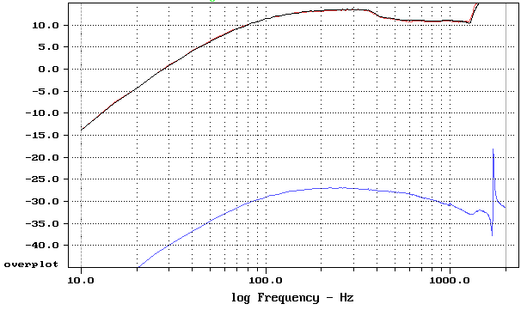

Fig 1 Cone and magnet acceleration Black – cone, magnet clamped
Red - cone, magnet free
Blue - magnet

It can be seen that the cone acceleration is almost identical in the two cases. On an expanded scale there is indeed a difference in the order of 0.1dB to 0.2dB, though this is within experimental error for the repeatability of this experiment.
The magnet acceleration is reduced in level by 40.2dB, which is consistent with the known mass ratios for this driver. The shape of response of the magnet acceleration is also a very close match to the diaphragm acceleration up until approximately 300Hz, where the attachment of the accelerometer and the stiffness of the cone begin to affect the measurement accuracy. This is shown in fig 2.

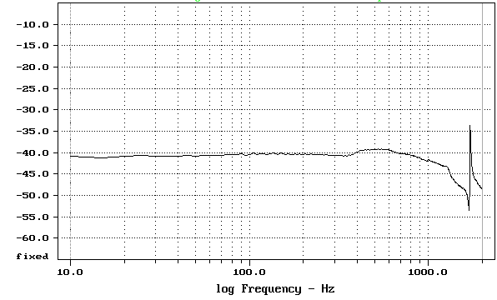
Fig 2 Ratio of magnet to diaphragm acceleration

Cabinet Responses

The driver was next mounted into the cabinet, both directly and via the isolating grommets, and the cone accelerations re-measured for both conditions.
These responses are shown in fig 3. The responses above 400Hz differ from those previously due to the re-attachment of the accelerometer. However, it is again clear that there is very little difference in cone acceleration, and hence farfield sound pressure response, in the two cases.

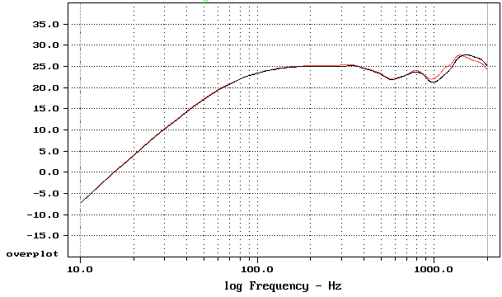
Fig 3 Cone acceleration response Black – coupled
Red - de-coupled

To determine how the magnet behaves when the chassis is rigidly coupled to, or de-coupled from, the box, acceleration measurements were made of the back of the magnet.
These responses are shown compared to the cone acceleration for scale. Fig 4.

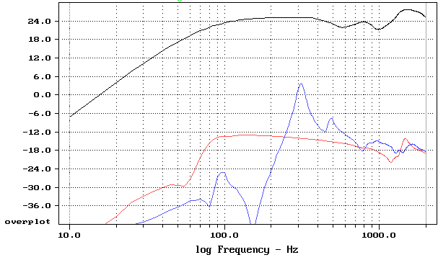
Fig 4 Magnet acceleration responses Black – cone
Red - chassis de-coupled
Blue - chassis coupled

From these responses, it is clear that the magnet for the coupled chassis is not behaving even close to the ideal, and is moving in a very complex manner, influenced by the resonant vibration modes of the cabinet and chassis. In contrast, the behaviour of the de-coupled chassis is much closer to the alternative ideal of a freely suspended system. This is further clarified by looking at the time behaviour of the two cases, as shown in fig 5.

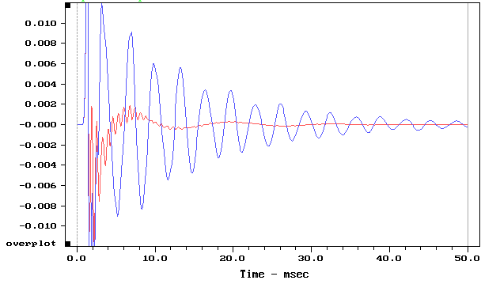
Fig 5 Magnet acceleration impulse responses Red – de-coupled
Blue – coupled

The impulse response of the coupled system rings on for much longer, due to the high Q nature of the resonances.

The improved nature of the magnet acceleration in the de-coupled case suggests that the cabinet excitation should be reduced. To confirm this, acceleration measurements were made of the cabinet panels. Only a single measurement was made on each panel, with the accelerometer attached to the centre of the panel. This does not show the full and complex nature of the panel vibrations, but is sufficient for the low order modes and for comparative purposes.
The following graphs show the behaviour of the back and side panel and are typical of the results obtained for all panels of the cabinet. Frequency and time responses are shown.

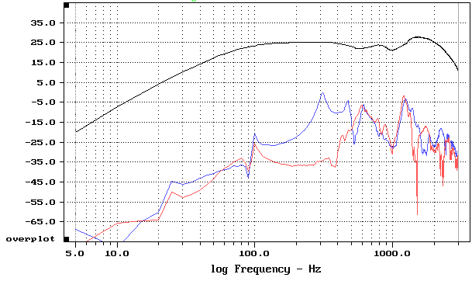
Fig 6 Back panel acceleration Black – cone
Red - chassis de-coupled
Blue - chassis coupled

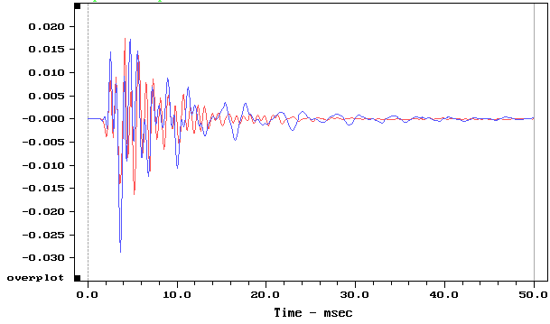
Fig 7 Back panel impulse responses Red – de-coupled
Blue – coupled

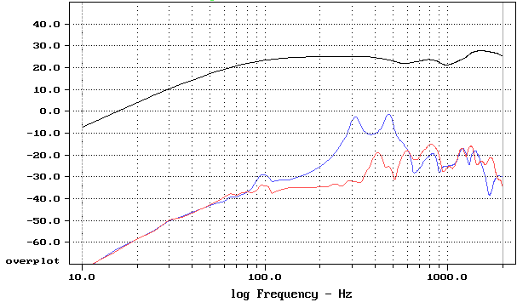
Fig 8 Side panel acceleration Black – cone
Red - chassis de-coupled
Blue - chassis coupled

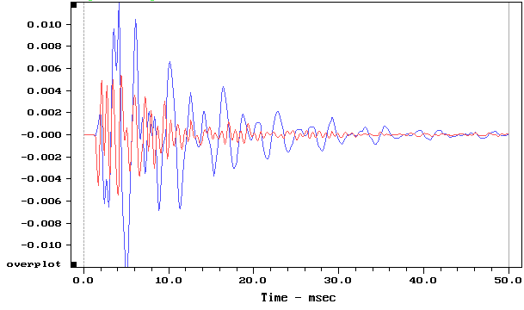

Fig 9 Side panel impulse responses Red – de-coupled
Blue – coupled

The responses shown in figs 6-9 clearly show a large reduction in cabinet vibration in the de-coupled condition, with improvements in the order of >20dB.
This confirms that the dominant excitation source is mechanical and not acoustical.
Of interest is the convergence of the two responses above approximately 500Hz.
It is conjectured that this is due to the non-rigid behaviour of the stamped steel chassis providing some degree of de-coupling. This could be confirmed by repeating the experiments using a more rigid chassis, such as cast magnesium.

Listening Tests

Two identical cabinets have been constructed and fitted with drive units (LF & HF) and crossover networks matched to +/-0.25dB.
One bass drive unit was de-coupled and the other mounted rigidly to the cabinet.
Anechoic measurements confirmed that the measured farfield responses were near identical.
Initial sighted listening tests were performed in mono, and a preference was indicated for the de-coupled system.
Further testing is required to fully quantify these conclusions, but early results are promising.

Conclusion

Experimental results of de-coupling experiments confirm that

- Diaphragm motion is minimally affected by de-coupling the drive unit from the cabinet
- Magnet motion, the “ground reference” for the cone motion, is better behaved when the drive unit is de-coupled
- Cabinet vibration is substantially reduced with a de-coupled drive unit

- Preliminary listening tests indicate a preference for the de-coupled drive unit

Further work will involve testing of the alternative proposed method of achieving de-coupling, confirming the correlation between predicted and measured results, and more listening tests.

